27.89: a) 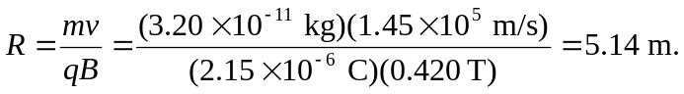
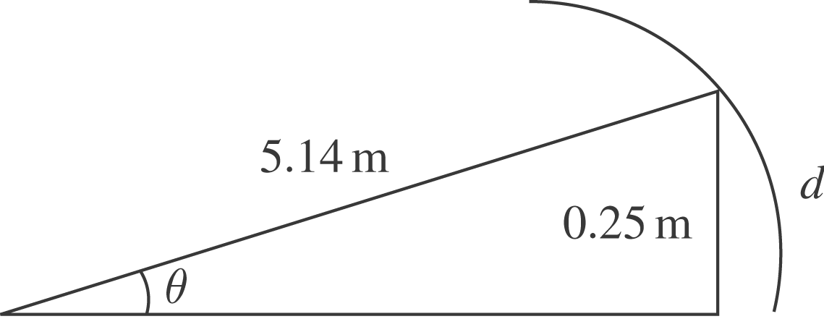

b) The distance along the curve, 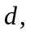is given by
And 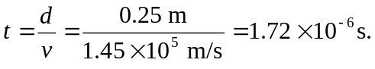
c)
d)

